CONTENTS
1. INTRODUCTION 1.1 Project Overview 1 1.2 Purpose 1
2. IDEATION PHASE 2.1 Problem Statement 2 2.2 Empathy Map Canvas 2 - 3 2.3 Brainstorming 3 - 6
3. REQUIREMENT ANALYSIS
3.1 Customer Journey map 6 - 9 3.2 Solution Requirement 9 - 10 3.3 Data Flow Diagram 10 - 12 3.4 Technology Stack 13 - 14 4. PROJECT DESIGN 4.1 Problem Solution Fit 15 -16 4.2 Proposed Solution 17 -19 4.3 Solution Architecture 19 -20 5. PROJECT PLANNING & SCHEDULING 5.1 Project Planning 21 -23 6. FUNCTIONAL AND PERFORMANCE TESTING 6.1 Performance Testing 24 - 26 7. RESULTS 7.1 Output Screenshots 27 8. ADVANTAGES & DISADVANTAGES 9. CONCLUSION 10. FUTURE SCOPE 11. APPENDIX Source Code (if any) 34-35 Dataset Link 35 GitHub & Project Demo Link

- INTRODUCTION
  - Project Overview
AutoSage is an intelligent automation system developed using Gemini Flash AI technology. The project focuses on building a smart, responsive, and scalable platform that automates tasks, processes user inputs, and generates accurate outputs in real time. By leveraging the fast processing capability of Gemini Flash, AutoSage enhances productivity and reduces manual effort in handling repetitive and data-driven operations.
The system is designed to analyze user queries, understand context, and provide meaningful responses through advanced AI processing. It integrates a user-friendly interface with backend AI services to deliver seamless automation solutions suitable for academic, business, and organizational applications.
AutoSage aims to bridge the gap between manual workflows and intelligent systems by offering a reliable AI-powered solution that supports decision-making, improves efficiency, and ensures high performance.
  - Purpose
The primary purpose of the AutoSage project is to develop an AI-driven automation platform that simplifies complex tasks and enhances operational efficiency. The system is intended to:
- Reduce manual workload and repetitive processing
- Provide fast and accurate AI-generated responses
- Improve productivity through intelligent automation
- Support data analysis and smart decision-making
- Deliver a scalable and user-friendly solution
Through the integration of Gemini Flash, the project demonstrates how advanced AI technologies can be effectively used to build smart automation systems for real-world applications.

2. IDEATION PHASE
2.1 Problem Statement
In today’s digital environment, individuals and organizations face challenges in managing repetitive tasks, processing large amounts of data, and generating quick responses efficiently. Manual handling of tasks leads to time consumption, reduced productivity, and increased chances of human error.
Although various tools exist, many systems lack intelligent automation, real-time processing, and contextual understanding of user requirements. There is a need for a smart system that can understand user queries, process them instantly, and generate meaningful outputs with minimal human intervention.
Therefore, the problem addressed in this project is:
To design and develop an AI-powered automation system that can understand user input, process information efficiently, and provide accurate, fast, and intelligent responses using Gemini Flash technology.
2.2 Empathy Map Canvas
To better understand user needs, an empathy analysis was conducted. The following insights were identified:
What the User Thinks
- Wants faster results
- Needs accurate and reliable outputs
- Expects easy-to-use systems
- Looks for automation to save time
What the User Feels
- Frustrated with repetitive manual tasks
- Overwhelmed by large data processing
- Concerned about errors and inefficiency
What the User Says
- “The process takes too much time.”
- “I need quick and accurate responses.”
- “Automation would make this easier.”
What the User Does
- Uses multiple tools for completing tasks
- Manually verifies information
- Repeats similar tasks regularly
Pain Points
- Time-consuming workflows
- Human errors
- Lack of intelligent automation
- Delayed responses
Gains
- Faster task completion
- Increased productivity
- Reduced manual effort
- Smart AI-assisted decision support
This analysis helped in designing a solution that directly addresses real user needs
2.3 Brainstorming
The brainstorming phase was conducted to explore multiple possible solutions for addressing the identified problem. Various approaches were discussed, evaluated, and compared based on feasibility, scalability, intelligence, cost, and performance.
1. Manual Workflow Optimization
Initially, improving the existing manual process was considered. This involved creating structured templates, predefined formats, and standardized procedures to reduce errors and improve efficiency.

Advantages:
- Easy to implement
- Low development cost
- No complex technology required
Limitations:
- Still time-consuming
- Requires human intervention
This approach was rejected because it does not eliminate manual dependency.
2. Rule-Based Automation System
The second idea was to design a rule-based automation system where predefined logic and conditions handle specific tasks.
Advantages:
- Faster than manual processing
- Suitable for repetitive structured tasks
- Easy to control outputs
Limitations:
- Cannot handle dynamic or complex queries
- Requires frequent rule updates
- Lacks contextual understanding
- Not adaptive to new scenarios
This approach was considered partially effective but insufficient for intelligent automation.
3. Basic Chatbot Implementation
A chatbot-based system was proposed to answer user queries and automate certain tasks.
Advantages:
- Interactive user interface
- Provides quick responses
- Improves user engagement
Limitations:
- Limited understanding capability
- Script-based responses
- Cannot handle complex reasoning
The limitation of contextual intelligence made this option less effective.
4. AI-Powered Automation Using Gemini Flash (Final Selected Idea)
After analyzing previous approaches, the team proposed integrating Gemini Flash AI to build an intelligent automation system capable of understanding context, processing dynamic inputs, and generating meaningful outputs in real time.
Key Features of the Selected Solution:
- Natural language understanding
- Real-time response generation
- Context-aware processing
- Scalable architecture
- Intelligent task automation
Advantages:
- High accuracy and adaptability
- Handles complex and dynamic queries
- Reduces human intervention significantly
- Improves productivity and efficiency
- Suitable for multiple application domains
This solution was selected because it provides advanced AI capabilities, flexibility, and long-term scalability compared to other options.
Final Decision
After evaluating all alternatives based on efficiency, scalability, intelligence, cost-effectiveness, and future expansion possibilities, the AI-powered automation system using Gemini Flash was finalized as the most suitable solution.
Thus, the concept of AutoSage was established as an intelligent automation platform designed to deliver smart, fast, and reliable AI-driven solutions.

3. REQUIREMENT ANALYSIS
3.1 Customer Journey Map
The Customer Journey Map represents the complete interaction process between the user and the AutoSage system. It explains how users engage with the system from the moment they identify a need until they receive the final output.
Stages in Customer Journey:
- Problem Identification
The user realizes the need for automation or intelligent assistance to complete a task efficiently.
- Query Submission
The user enters the input or query into the AutoSage system through the user interface.
- AI Processing
The system forwards the input to the processing module where Gemini Flash analyzes the request, understands context, and generates relevant information.
- Output Generation
The processed result is structured and prepared in a readable format.
- User Review and Utilization
The user reviews the generated output and applies it to their task. If needed, additional queries can be submitted.
This structured journey ensures smooth interaction, minimal delay, and improved user satisfaction.
3.2 Solution Requirements
The requirements of autosage are categorized into functional and non-functional
Requirements.
A. Functional Requirements
- The system must accept user input in text format.
- The system must validate and process input queries.
- The system must integrate with Gemini Flash API.
- The system must generate accurate and contextual responses.
- The system must display output clearly to the user.
- The system should maintain logs of interactions (if required).
- The system should allow multiple user interactions.
B. Non-Functional Requirements
- The system must provide high performance with low response time.
- The system must be scalable to support multiple users.
- The system must ensure data security and privacy.
- The system must have a user-friendly interface.
- The system must be reliable and available with minimal downtime.
- The system should maintain accuracy and consistency.
3.3 Data Flow Diagram
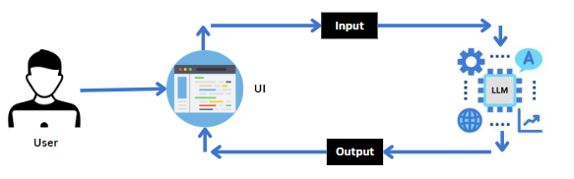
The Data Flow Diagram (DFD) explains how data moves within the AutoSage system.
Data Flow Process
1.User Input
The user submits a query through the interface.
2. Input Processing Module
The system receives and preprocesses the input data.
3.Gemini Flash API Integration
The processed data is sent to Gemini Flash for intelligent analysis and response generation.
4.Response Module
The AI-generated response is formatted properly.
5.Output Display
The final result is displayed to the user.
This flow ensures structured data movement, efficient processing, and quick response generation.
3.4 Technology Stack
The technology stack defines the tools and technologies used to develop AutoSage.
Frontend Technologies
- HTML
- CSS
- JavaScript
Used to create a responsive and user-friendly interface.
Backend Technologies
- Python / Node.js
Used for handling server-side logic, API communication, and processing tasks.
Artificial Intelligence Integration
- Gemini Flash API
Used for intelligent processing, contextual understanding, and response generation.
Database (Optional)
- SQL or NoSQL Database
Used for storing user queries, logs, and system data if required.
Deployment Environment
- Cloud platform or Local server
Ensures scalability, reliability, and accessibility.
4.PROJECT DESIGN

4.1 Problem Solution Fit
The primary problem identified in this project is the inefficiency of manual processes and the lack of intelligent automation in handling repetitive and data-driven tasks. Users require a system that can process information quickly, reduce manual effort, and provide accurate responses in real time.
AutoSage addresses this problem by integrating Gemini Flash AI to create an intelligent automation platform. The solution aligns with user needs by:
- Providing real-time AI-generated responses
- Reducing manual workload
- Improving accuracy and consistency
- Supporting dynamic and complex queries
- Enhancing productivity
The system ensures a strong problem-solution fit by directly targeting inefficiencies and replacing them with AI-driven automation.
4.2 Proposed Solution
The proposed solution is the development of AutoSage, an AI-powered intelligent automation system that leverages Gemini Flash for fast and contextual processing.
Key Components of the Proposed Solution:
1.User Interface Module
A simple and user-friendly interface where users can enter queries and receive outputs.
2.Processing Module
Handles input validation and prepares data for AI processing.
3.Gemini Flash Integration
The core AI engine that processes queries, understands context, and generates meaningful responses.
4.Response Generation Module
Formats the AI output into a structured and readable form.
5.Output Display Module
1. Presents the final result clearly to the user.
2. The proposed system ensures scalability, flexibility, and high performance
While maintaining simplicity for end users.
4.3 Solution Architecture
The architecture of AutoSage is designed using a layered approach to ensure modularity and scalability.
1. Presentation Layer (Frontend)
This layer interacts directly with the user. It collects input and displays results. Technologies such as HTML, CSS, and JavaScript are used to build a responsive interface.
2. Application Layer (Backend)
This layer manages business logic and processes user requests. It communicates with the Gemini Flash API and handles data formatting.
3. AI Integration Layer
This layer integrates Gemini Flash, which performs natural language processing, contextual understanding, and intelligent response generation.
4. Data Layer (Optional)
This layer stores user logs, interaction history, or configuration data using a database if required.
Architecture Flow Explanation:
User → Frontend Interface → Backend Processing → Gemini Flash API → Response Formatting → Output Display
This architecture ensures:
- Efficient communication between modules
- Faster response time
- Easy maintenance and upgrades
- Scalable system performance

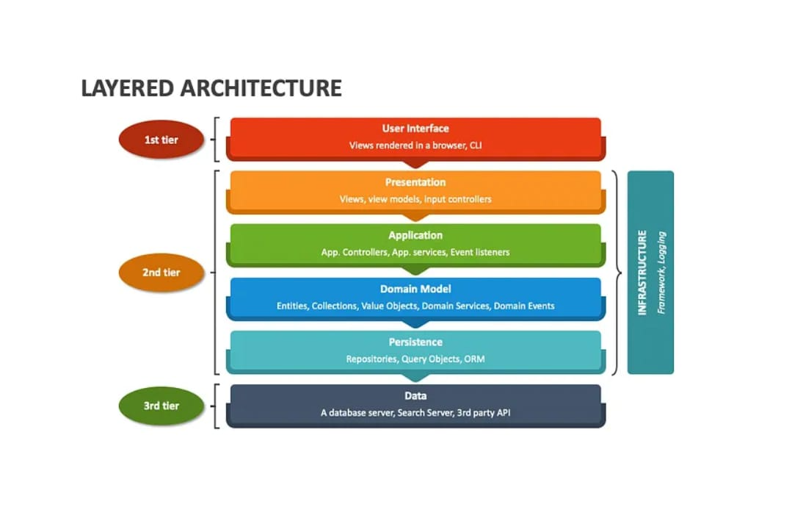
fig: LAYERED ARCHITECTURE

5. PROJECT PLANNING & SCHEDULING
5.1 Project Planning
Project planning plays a crucial role in ensuring the successful development and implementation of the AutoSage system. This phase focuses on organizing tasks, allocating resources, defining timelines, and establishing a structured development approach. Proper planning helps in minimizing risks, improving coordination, and ensuring that the project is completed within the specified duration.
The first stage of planning involved requirement gathering. During this stage, the needs of users were carefully analyzed, and the limitations of existing systems were identified. The objectives of the project were clearly defined, and both functional and non-functional requirements were documented. Special attention was given to understanding the capabilities of Gemini Flash and how it could be integrated effectively into the system.
After requirement analysis, the system design phase was initiated. In this stage, the overall architecture of AutoSage was designed using a layered architectural approach to ensure modularity and scalability. Data Flow Diagrams were prepared to illustrate how information moves within the system. The technology stack was finalized, and the structure of the user interface was planned to ensure ease of use and responsiveness.
The development phase followed the design phase. During development, the frontend interface was created to allow users to interact with the system smoothly. The backend logic was implemented to handle business processes and API communication. Gemini Flash was integrated into the system to enable intelligent processing and response generation. If required, database connectivity was established to store logs and user interactions.
Once development was completed, the system entered the testing phase. Functional testing was performed to verify that all features operated correctly according to the requirements. Performance testing was conducted to evaluate response time and system stability. API responses were validated to ensure accuracy and reliability. Errors were identified and resolved to improve overall system quality.
After successful testing, the deployment phase was carried out. The system was configured for deployment in the chosen environment, either cloud-based or local server-based. Final validation was conducted to ensure smooth functioning. Documentation was completed, and the system was prepared for demonstration and submission.
Project Scheduling
The project was scheduled in a systematic manner to ensure timely completion. The entire development process was divided into multiple phases, each assigned a specific duration. Requirement analysis was completed during the initial stage of the project timeline, followed by system design. Development activities were carried out in the subsequent weeks, ensuring continuous progress. Testing was conducted after development to validate system performance and reliability. The final phase focused on deployment and documentation.
An Agile-based approach was adopted for managing the project. This approach allowed iterative improvements, flexibility in modifications, and continuous monitoring of progress. Regular reviews were conducted to track milestones and ensure that each phase met the defined objectives.
Risk management was also considered during planning. Potential risks such as API integration issues, performance delays, and data security concerns were identified early in the project. Appropriate mitigation strategies were planned to handle these risks effectively. Resource planning was carefully done to ensure the availability of development tools, API access, testing environments, and documentation support.
Overall, the structured planning and scheduling approach ensured that the AutoSage project was developed efficiently, maintained quality standards, and achieved its intended objectives within the planned timeframe.
Risk Management
Potential risks identified:
- API integration failure
- Performance latency issues
- Data security concerns
- Deployment configuration errors
Mitigation strategies included:
- Early API testing
- Performance optimization
- Secure API handling
- Backup and recovery planning

- FUNCTIONAL AND PERFORMANCE TESTING
6.1 Performance Testing
Functional testing was conducted to verify that the AutoSage system performs according to the specified requirements. The main purpose of this testing phase was to ensure that the system correctly accepts user input, processes the request using Gemini Flash, and generates meaningful and accurate responses. The testing process focused on validating the interaction between the frontend interface, backend logic, and the Gemini Flash API integration.
During testing, different types of user queries were submitted through the interface to observe system behavior. The system was verified to ensure that it accepts valid input, prevents empty submissions, and properly forwards the query to the backend server. The backend processing module was tested to confirm that it formats the request correctly and communicates successfully with the Gemini Flash API. The responses received from the API were examined to ensure they were contextually relevant and properly structured before being displayed to the user.
The system was also tested under various scenarios such as simple queries, complex queries, and repeated consecutive inputs. Error handling mechanisms were verified by simulating network interruptions and invalid inputs to ensure that appropriate error messages were displayed without affecting overall system stability. The results of functional testing confirmed that the AutoSage system performs all required operations accurately and reliably.
Performance Testing:
Performance testing was carried out to evaluate the efficiency, responsiveness, and reliability of the AutoSage system under different usage conditions. The main objective of this testing was to measure the time taken for the system to generate responses and to assess the stability of the application during continuous operation.
The response time was measured from the moment a user submits a query to the moment the generated answer is displayed on the screen. The system demonstrated satisfactory performance, with response time primarily dependent on the latency of the Gemini Flash API. The communication between the backend and the API remained stable throughout the testing process.
The system was tested with multiple consecutive queries to observe its behavior under continuous usage. It maintained consistent performance without noticeable degradation in speed or accuracy. The architecture of the system was evaluated for scalability, ensuring that it can handle increased user interactions when deployed in a production environment. Overall, the AutoSage system exhibited reliable performance, stable API integration, and efficient response handling.
Conclusion Of Testing:
The testing phase confirmed that the AutoSage system functions correctly and meets the intended project objectives. Functional testing verified accurate query processing and response generation, while performance testing demonstrated stable and efficient operation. The integration with Gemini Flash proved to be reliable, making the system suitable for real-time intelligent assistance applications.

- RESULTS


Fig: input
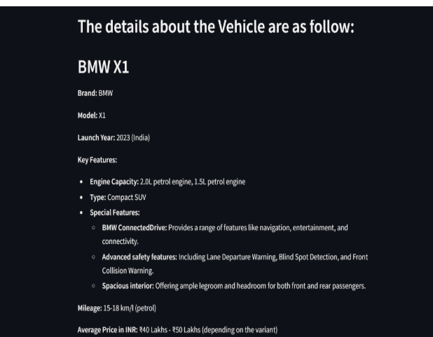
Fig: Output
1. The AutoSage app takes a vehicle image as input from the user.·
2. It uses Gemini 1.5 Flash AI model to analyze the image.
3. The model identifies the vehicle brand and model from visual features.
4.It generates detailed information like launch year, mileage, price, and key features.
5.The output is displayed in a structured format using Streamlit.
6.The app provides quick and accurate vehicle details automatically.
7.It uses Python, Streamlit, and Google Generative AI technologies.
8.This app is useful for vehicle identification and automobile information systems.

8. ADVANTAGES AND DISADVANTAGES
8.1 Advantages
- Provides real-time and fast response generation.
- Reduces manual effort by automating information processing.
- Improves productivity and efficiency.
- Supports natural language interaction for easy usage.
- Generates context-aware and meaningful responses.
- Modular and scalable architecture.
- Can be integrated into multiple applications such as education and business
- tools.
- Easy to maintain and upgrade.
- Enhances user experience with intelligent assistance.
- Flexible and adaptable to different use cases
  - Disadvantages
- Requires stable internet connectivity to function.
- Fully dependent on the Google Gemini Flash API.
- API latency may affect response time.
- Possible API usage limits or pricing restrictions.
- Responses may require human verification for sensitive information.
- Data privacy and security concerns if not properly managed.
- Performance depends on backend server capacity.
- Limited offline functionality.

9. CONCLUSION
The AutoSage project successfully demonstrates the development of an intelligent automation system integrated with Gemini Flash for real-time query processing and response generation. The system was designed using a structured and layered architecture to ensure modularity, scalability, and efficient communication between components. By integrating advanced AI capabilities, AutoSage enables users to interact with the system using natural language and receive meaningful, context-aware responses.
Throughout the development process, careful attention was given to requirement analysis, system design, implementation, and testing. Functional testing confirmed that the system performs all intended operations accurately, while performance testing verified stable and efficient response handling. The integration with Google Gemini Flash proved to be reliable and effective for intelligent information processing.
The project highlights the importance of AI-driven automation in improving productivity and reducing manual effort. AutoSage provides a flexible and adaptable solution that can be extended to various applications such as education, business support, and intelligent assistance platforms. Although the system has certain limitations such as dependency on internet connectivity and API services, it successfully achieves its core objective of delivering an efficient AI-powered automation tool.
In conclusion, the AutoSage system represents a practical and scalable implementation of modern AI technology, demonstrating how intelligent models like Gemini Flash can be effectively utilized to build smart and responsive applications

10. FUTURE SCOPE
The AutoSage project has significant potential for future enhancements and expansion. Currently, the system provides intelligent text-based responses using Gemini Flash, but it can be further developed into a more advanced and versatile AI platform.
In the future, AutoSage can be extended to support multi-modal capabilities such as voice input and speech-based responses. This would enable users to interact with the system through voice commands, making it more accessible and user-friendly. Integration with speech recognition and text-to-speech technologies can transform AutoSage into a complete virtual assistant.
The system can also be enhanced by incorporating personalization features. By maintaining user interaction history and preferences, AutoSage can provide more customized and context-aware responses. This would improve user experience and increase system efficiency over time.
Another potential improvement is mobile and cloud deployment. Developing a dedicated mobile application or deploying the system on scalable cloud infrastructure would allow it to support a larger number of users simultaneously. This would make the system suitable for enterprise-level applications.
AutoSage can also be integrated with other software systems such as learning management systems, business automation platforms, or customer support tools. This integration would expand its practical applications across different industries.
In addition, advanced security mechanisms can be implemented to enhance data privacy and protection. Features such as encrypted communication, authentication systems, and secure API management can strengthen system reliability.
Overall, the future scope of AutoSage is vast, and with further development, it can evolve into a comprehensive AI-powered intelligent assistant platform capable of supporting diverse real-world applications.
- APPENDIX
Source Code:
### Health Management APP

from dotenv import load_dotenv

load_dotenv() ## load all the environment variables

import streamlit as st
import os
import google.generativeai as genai
from PIL import Image

genai.configure(api_key=os.getenv("GOOGLE_API_KEY"))

## Function to load Google Gemini Pro Vision API And get response
def get_gemini_response(input_prompt, image):
model = genai.GenerativeModel('gemini-2.5-flash')
response = model.generate_content([input_prompt, image[0]])
return response.text
def input_image_setup(uploaded_file):
# Check if a file has been uploaded
if uploaded_file is not None:
# Read the file into bytes
bytes_data = uploaded_file.getvalue()

image_parts = [
{
"mime_type": uploaded_file.type, # Get the mime type of the uploaded file
"data": bytes_data
}
]
return image_parts
else:
raise FileNotFoundError("No file uploaded")

## initialize our streamlit app
input_prompt="""
You are a automobile expert tasked with providing a detailed overview of any vehicles
The information should be presented in a structured format as follows:
Brand: Name of the vehicle brand.
Model: Specific model of the vehicle.
Launch year: Since when the Vehicle is available in market
Key Features: Describe the engine capacity, type (e.g., scooter, motorcycle, sedan, SUV), and special features(any top 3)
(e.g., ABS, digital display, storage capacity, safety features).
Mileage: Provide the average mileage in km/l (kilometers per liter).
Average Price in INR: Mention the price range of the vehicle model.
Other Details: Include information on maintenance costs, additional benefits, and any unique selling points.
Approximate Resale Value: Estimate the resale value of the vehicle after 10 years in Indian Rupees.

"""
st.set_page_config(page_title='Welcome')
st.header('AutoSage App')

uploaded_file = st.file_uploader("Choose an image...", type=["jpg", "jpeg", "png"])
image=""
if uploaded_file is not None:
image = Image.open(uploaded_file)
st.image(image, caption="Uploaded Image.", use_column_width=True)

submit=st.button('Submit')
if submit:
image_data=input_image_setup(uploaded_file)
response= get_gemini_response(input_prompt, image_data)
st.header('The details about the Vehicle are as follow:')
st.write(response)

Github and Project Demo link:
Github Link:
https://github.com/gudichandana/Autosage-App-Using-Gemini-Flash-
Project Demo Link:
https://drive.google.com/file/d/1p2gEURj0mCkbRmbryMNzduxYzVfX69j/view?usp=drive_link

